Children’s Rights and Entitlements Policy
Safeguarding and Welfare Requirements

3.1. Children learn best when they are healthy, safe and secure, when their individual needs are met, and when they have positive relationships with the adults caring for them. The safeguarding and welfare requirements, specified in this section, are designed to help providers create high quality settings which are welcoming, safe and stimulating, and where children are able to enjoy learning and grow in confidence.

Statement of Intent

Bishopthorpe Preschool Playgroup believe that it is a child's right to be strong, resilient and listened to by creating an environment in our Playgroup that encourages children to develop a positive self image, including their heritage arising from their colour and ethnicity, the languages spoken, their religious beliefs, cultural traditions and home background. We promote every child's right to be strong, resilient and listened to by:

- encouraging every child to develop a sense of autonomy and independence.
- enabling children to have the self-confidence and the vocabulary to resist inappropriate approaches.
- We help children to establish and sustain satisfying relationships within their families, with peers, and with other adults.
- We work with parents to build their understanding of, and commitment to, the principles of safeguarding all our children.

What it means to promote children’s rights and entitlements to be ‘strong, resilient and listened to’.
To be strong means to:
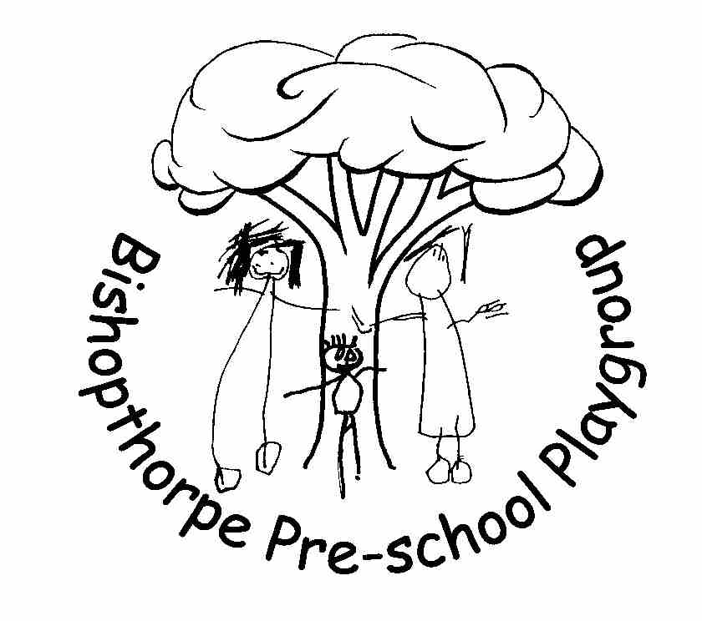
- be secure in their key relationships where they are loved and cared for, by at least one person who is able to offer consistent, positive and unconditional regard and who can be relied on;
- be safe and valued as individuals in their families and in relationships beyond the family, such as day care or school;
- be self assured and form a positive sense of themselves – including all aspects of their identity and heritage;
- be included equally and belong in early years settings and in community life;
- be confident in abilities and incredibly proud of their achievements;
- be progressing optimally in all aspects of their development and learning;
- be part of a peer group in which to learn to negotiate, develop social skills and identity as an individual, respecting the rights of others in a diverse world;
- participate and be able to represent themselves in aspects of service delivery that affects them as well as aspects of key decisions that affect their lives.

To be resilient means to:
- be sure of their self worth and dignity;
- be able to be assertive and state their needs confidently and effectively;
- be able to overcome difficulties and problems;
- be positive in their outlook on life;
- be able to cope with challenges and change;
- have a sense of justice towards self and others;
- develop a sense of responsibility towards self and others; and
- be able to represent themselves and others in key decision making processes.

To be listened to means:
- adults who are close to children recognise their need and right to express and communicate their thoughts, feelings and ideas;
- adults who are close to children are able to understand and interpret their verbal, sign and body language in order to understand and interpret what is being expressed and communicated;
- adults who are close to children are able to respond appropriately and, when required, act upon their understanding of what children express and communicate;
- adults respect children’s rights and facilitate children’s participation and representation in imaginative and child centred ways in all aspects of core services.

This Policy was adopted at a meeting of Bishopthorpe Preschool Playgroup
Held on ___________________________
Signed on behalf of Bishopthorpe Preschool Playgroup ___________________________
Role of Signatory Chairperson
Date of next substantive review October 2022

