Food and Drink Policy
Safeguarding and Welfare Requirements - Food and Drink

3.48.Where children are provided with meals, snacks and drinks, they must be healthy, balanced and nutritious. Before a child is admitted to the setting the provider must also obtain information about any special dietary requirements, preferences and food allergies that the child has, and any special health requirements. Fresh drinking water must be available and accessible to children at all times. Providers must record and act on information from parents and carers about a child's dietary needs.

3.49.There must be an area which is adequately equipped to provide healthy meals, snacks and drinks for children as necessary. There must be suitable facilities for the hygienic preparation of food for children, if necessary including suitable sterilisation equipment for babies’ food. Providers must be confident that those responsible for preparing and handling food are competent to do so. In group provision, all staff involved in preparing and handling food must receive training in food hygiene. In addition, section 4 of ‘Example menus for early years settings in England’ includes guidance on menu planning, food safety, managing food allergies and reading food labels, which staff preparing food will find helpful in ensuring that children are kept safe.
Statement of Intent

Bishopthorpe Preschool playgroup considers snack and meal times as an important part of the Playgroup's day. Eating represents a social time for children and adults and helps children to learn about healthy eating. We promote healthy eating using resources and materials from ‘Eat Better, Start better’ by the Children’s Food Trust. At snack and meal times, we aim to provide nutritious food, which meets the children's individual dietary needs.

Procedures
We follow these procedures to promote healthy eating in our Playgroup.
- Before a child starts to attend the Playgroup, we find out from parents their children's dietary needs and preferences, including any allergies. (See Managing children with allergies and infections policy.)
- We document information about each child's dietary needs on her/his registration form and parents sign the record to signify that it is correct.
- We regularly consult with parents to ensure that our records of their children's dietary needs - including any allergies - are up-to-date. Parents sign the up-dated record to signify that it is correct.
- We display current information about individual children's dietary needs so that all staff and volunteers are fully informed about them.
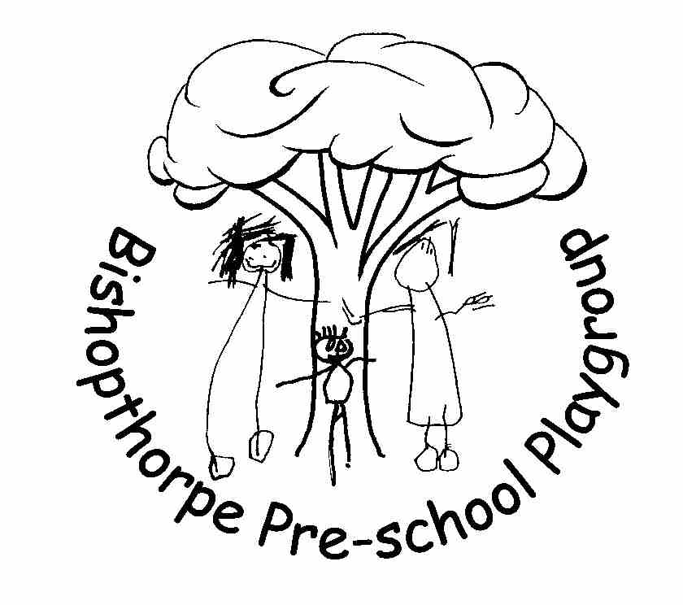
- We implement systems to ensure that children receive only food and drink that is consistent with their dietary needs and preferences as well as their parents' wishes.
- We provide nutritious food for all snacks, avoiding large quantities of saturated fat, sugar and salt and artificial additives, preservatives and colourings.
- We take care not to provide food containing nuts or nut products and are especially vigilant where we have a child who has a known allergy to nuts. We currently enforce a ‘Nut free zone’ on the premises.
- Through discussion with parents and research reading by staff, we obtain information about the dietary rules of the religious groups, to which children and their parents belong, and of vegetarians and vegans, and about food allergies. We take account of this information in the provision of food and drinks.
- We require staff to show sensitivity in providing for children's diets and allergies. Staff do not use a child's diet or allergy as a label for the child or make a child feel singled out because of her/his diet or allergy.
- We organise snack times so that they are social occasions in which children and staff participate.
- We use snack times to help children to develop independence through making choices, serving food and drink and feeding themselves.
- We provide children with utensils that are appropriate for their ages and stages of development and that take account of the eating practices in their cultures.
- We have fresh drinking water constantly available for the children. We inform the children about how to obtain the water and that they can ask for water at any time during the day.

Packed lunches

When children stay over lunch, they bring a packed lunch
- We inform parents who provide food for their children about the storage facilities available in the Playgroup.
- We give parents who provide food for their children information about suitable containers for food.
- In order to protect children with food allergies, we discourage children from sharing and swapping their food with one another.
- For children who drink milk, we provide semi-skimmed milk and an Oat alternative where necessary.
- We advise parents to use an ice pack to keep perishable contents of packed lunches cool;
- We inform parents of our policy on healthy eating;
- We encourage parents to provide sandwiches with a healthy filling, fruit, and milk based desserts such as yoghurt. We discourage sweet drinks and can provide children with water
- We discourage packed lunch contents that consist largely of crisps, processed foods, sweet drinks and sweet products such as cakes or biscuits. We do this by giving parents an advice sheet on what to include in a healthy packed lunch and details of the www.childrensfoodtrust.org.uk where further information can be obtained.
- We ensure staff sit with children to eat their lunch so that the mealtime is a social occasion.
- We exercise a ‘nut free zone’ at playgroup.

This Policy was adopted at a meeting of Bishopthorpe Preschool Playgroup
Held on ___________________________
Signed on behalf of Bishopthorpe Preschool Playgroup ___________________________
Role of Signatory Chairperson
Date of next substantive review October 2023

